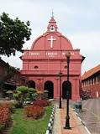

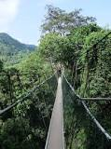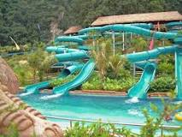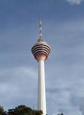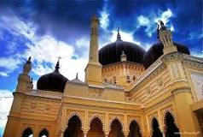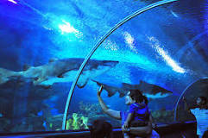

**Nationaal park Taman Negara**

**in Pahang**

**Zahir Mosque**

**in Kedah**

**Lost World of Tambun**

**in Perak**

**Kuala Lumpur Tower**

**in Kuala Lumpur**

**Aquarium KLCC in**

**Kuala Lumpur**

**Christ Church**

**in Malakka**