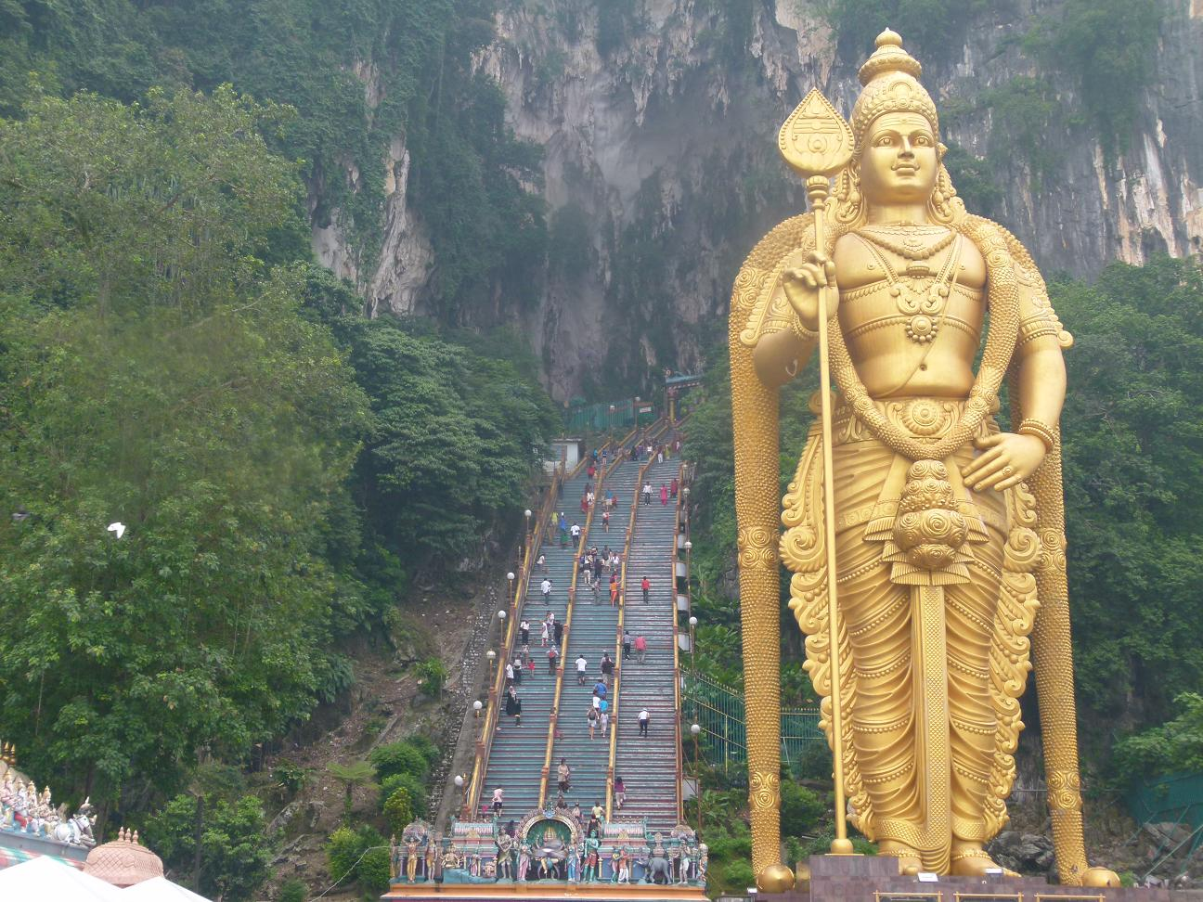 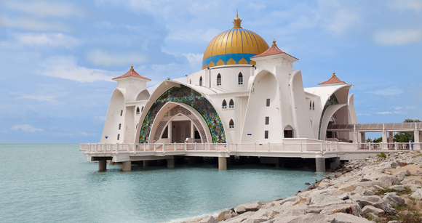

**Batu Caves in**

**Kuala Lumpur**

**Malaka Moskee in Malakka**

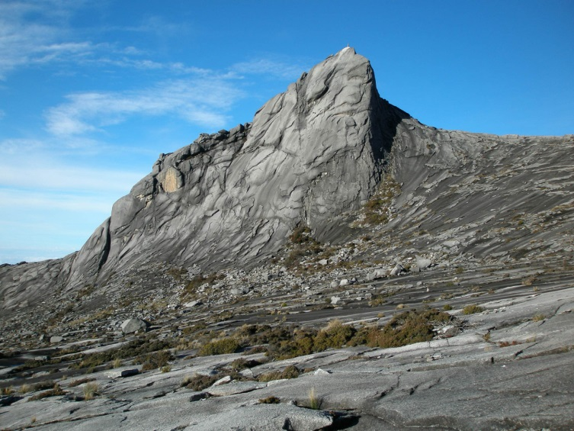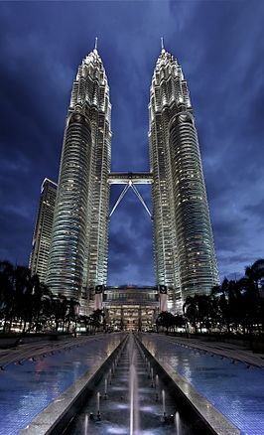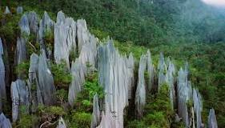 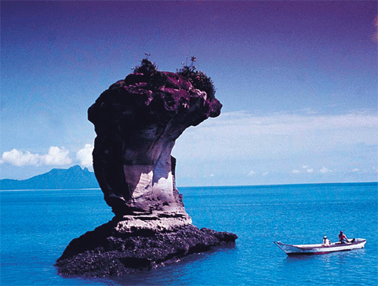

**Bako National Park**

**in Sarawak**

**Petronas Twin Towers**

**in Kuala Lumpur**

**r**

**Nationaal park Gunung Mulu**

**in Sarawak**

**Mount Kinabalu in**

**Sabah-Borneo-Maleisië**